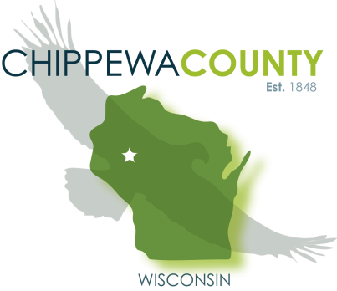
Criminal Justice Services Division
Chippewa County COMPAS Process
Rose Baier, CJS Director

Making a COMPAS Referral:
- Use the current version of the referral form
- This must be fully completed using the client’s most current information.
- All known case information must be filled in. The client information must include their full name, including middle initial, as well as birth date and contact information. If the client does not have a phone number at which they can be reached, it will be the client’s responsibility to contact the Assessor. Please check a “Reason for Evaluation” box.

Scheduling an Appointment:
- Once criminal history information is verified, the assessor will contact the client to schedule an appointment to be held within five days.
- The completion of a COMPAS may be delayed if contact information is invalid or the client is not returning the assessor’s call. The assessor will make two attempts to contact the client. After the second unsuccessful attempt the referring party will be notified and asked to have their client contact the assessor to schedule an appointment.
- If the client fails to show up for the scheduled appointment the assessor will make one attempt to contact the client to reschedule. The assessor will also contact the referring party to alert them of the missed appointment. If the client fails to contact the assessor within one week, the assessor will ask the referring party to have the client contact the assessor to reschedule the appointment. Referrals will be held open for 30 days. If there is no follow through after this time the referral will be terminated and the referring party will have to submit a new referral.
- If a client arrives more than 10 minutes late for an appointment the COMPAS Assessment will not be completed and they will be asked to schedule for a different day.
- Once an assessment is completed the assessor will have a summary of the results sent to the referring party, and any other involved parties listed on the referral form, within 24-48 hours.

Additional Assessment Descriptions

NIJ Mental Health Screens
- Separate questionnaires for men and women. The men’s contains 12 yes/no questions, while the women’s contains eight, about current and lifetime indications of serious mental disorder.
- Six questions regarding symptoms and history of mental illness; remaining questions are unique to each gender screen.
- Recommendation for further evaluation: Males- 6 or more “Yes” responses; Females- 5 or more “Yes” responses.

TCU Drug Screen
- A 15-item questionnaire that determines a person’s need for further AODA evaluation.
- Recommendation for further evaluation: If the offender’s score is 3 or higher.

TCU Criminal Thinking
- Thirty-seven item questionnaire that uses a 5-point Likert scale to measure an offender’s criminal thinking based on six categories: Entitlement, Justification, Personal Irresponsibility, Power Orientation, Cold Heartedness, and Criminal Rationalization.
- Recommendation for further evaluation: If the offender scores “Medium” in two categories or “High” in one.

Impaired Driving Assessment “IDA”
- The IDA is a differential screening instrument that consists of 45 items across two components designed to estimate the risk for future impaired driving, provide preliminary guidelines for service needs, estimate the level of responsivity to supervision and services, and identify the degree to which traffic safety has been jeopardized among individuals convicted of OWI offenses.
- The IDA has eight domains that assess a handful of major areas of impaired-driving recidivism: prior involvement in the justice system related to impaired driving, as well as in general; prior involvement with alcohol and or/other drugs; mental health and mood adjustment problems; and resistance to or non-compliance with the justice system interventions.

If you have any questions about this process, please feel free to contact: Rose Baier at rbaier@chippewacountywi.gov

